Macroeconomics 2
Normal Exam, June 11, 2021 (Model Answers)

- The exam lasts two hours (6pm-8pm, except for students with special educational needs).
- Answer each group of questions on a separate sheet, being careful to write your name on each sheet.
- Read the questions carefully and answer them succinctly, in legible handwriting. Present the calculations, if applicable, and, in the case of theoretical questions, explain your reasoning by answering each of the items.
- You can use a calculator without communication capability, as well as use the page with formula written by you, as indicated in the regulations.

Group 1 (5 points)
Consider an economy that works according to the hypotheses of the Solow model and whose production function has the usual Cobb-Douglas form:
Y = A.K^{α}.L^{1-α}
It is additionally known that the technology level is constant and equal to 5; that the partial elasticity of output to physical capital is 0.6; that the depreciation rate is 4% per year; that the population grows at 1% a year; and that the stock of physical capital per worker in the steady state has the value of 1000 monetary units.
1.1. (1 value) Calculate the savings rate consistent with this steady state.
Y = 5.K^{0,6}.L^{0,4}
y=5k^{0,6}
In steady state:
y=5*1000^{0,6}=315,5~
s*y=(n+δ)*k
s*315,5=(0,01+0,04)*1000
s=50/315,5=15,8%

1.2. (2 values) What will happen to labor productivity in this economy if the savings rate increases? Graphically represent this change and the resulting effect on labor productivity.

1.2
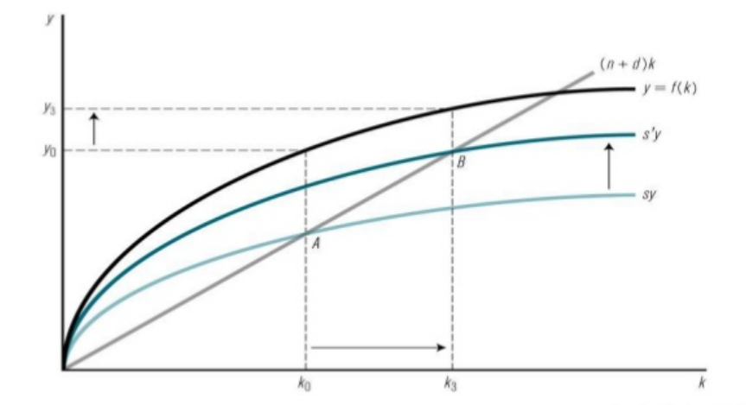
The increase in the savings rate, s, is graphically reflected in the transition from the savings function sy to s’y. The steady-state equilibrium, resulting from the intersection of the savings function with the necessary investment function, thus passes from A to B, corresponding to the passage from k=k0 to k=k3 (according to the notation used in this figure). The effect of this steady state change on productivity, y, is an increase from y0 to y3 (according to the notation used here).

1.3. (2 points) In what sense is economic growth exogenous in Solow's model and endogenous in Romer's model? Briefly explain.

Growth is exogenous in the Solow model in the sense that, once the steady state is reached, economies only grow in intensive terms (per capita) through technical progress that “falls from the sky” and is not explained by the model. In Romer's model, on the other hand, the growth dynamic is explained by the model and generated endogenously, resulting from a technical progress (production of new ideas) that results from the activity of a part of the population that is dedicated to R&D activities, being by this is ultimately a function of population growth.

Group 2 (5 points)
Consider the following table, which represents the evolution of the S80/S20 ratio in Portugal between 2005 and 2019.
 | 2005 | 2006 | 2007 | 2008 | 2009 | 2010 | 2011 | 2012 | 2013 | 2014 | 2015 | 2016 | 2017 | 2018 | 2019
S80/S20 | 6,7 | 6,5 | 6,1 | 6,0 | 5,6 | 5,7 | 5,8 | 6,0 | 6,2 | 6,0 | 5,9 | 5,7 | 5,2 | 5,2 | 5,0

2.1 (1 value) Explain what it consists of, how it is calculated and what the S80/S20 ratio is used for.

The S80/S20 ratio is an indicator of income inequality that takes into account the extremes of the distribution. It is calculated by dividing the share of income earned by the quintile (20%) of the population with the highest income by the share of income earned by the quintile (20%) of the population with the lowest income. The higher the value of this indicator, the greater the income inequality in the period in question.

2.2 (2 point) Briefly discuss its evolution over the period under analysis, relating it to the phases of the economic cycle in Portugal.

In the period under review, we found that income inequality as measured by this indicator decreased in the economic expansion phases (2005-2009 and 2013-2019), having worsened during the severe economic crisis that Portugal went through between 2009 and 2013.
One of the central factors for this evolution of inequality was the evolution of unemployment, whose strong increase severely penalized the income of the poorest 20% in the period 2009-2013, and whose reduction in periods of expansion allowed to attenuate the disparity between the extremes of the distribution. In addition to the evolution of the economy, politically determined measures also contributed – for example, related to the evolution of pensions or the minimum wage. The evolution of inequality indicators is thus related, among other factors, to (i) the policies applied, as in the case of the period under the troika program in Portugal, (ii) the cyclical fluctuations of the economy, given that recessions tend to aggravate inequality, unless effective anti-cyclical policies are implemented.

2.3 (2 values) Briefly explain the meaning of the expression “r>g” in the theoretical framework proposed by Thomas Piketty.

In his various works, Thomas Piketty has documented and sought to explain the evolution of wealth and income inequality throughout history and in contemporary societies. Its best-known hypothesis, r>g, states that the return on capital (r) tends to be systematically higher than the growth rate of the
product/income of the economy as a whole (g).
Since Piketty understands capital as synonymous with wealth or heritage, r>g implies that property holders are able to systematically grow that heritage at a higher rate than the economy as a whole, generating a mechanism in which inequality it perpetuates and deepens.

Group 3 (5 points)
3.1 (2 points) Consider a pay-as-you-go social security system that is in equilibrium. Over the next ten years, the government predicts that labor productivity will increase by 3% each year, that the functional distribution of income will remain unchanged, that the weight of pensioners in the total population will increase by 2% each year and that the employment rate (relative to the total population) will decrease by 1% each year. What should be the evolution of the average pension in this period for the system to remain in balance, if the government is not willing to change the rate of social security discounts?

r(b)+r(w)+r(L)=r(Nr)+r(P)
0+0,03+[-0,01+r(N)]=[0,02+r(N)]+r(P)
r(P)=0 In these conditions, the average pension cannot increase.

3.2 (2 value) Based on the equilibrium condition of a pay-as-you-go social security system, identify five measures that could contribute to the financial sustainability of that same system and briefly indicate their social impacts.

r(b)+r(w)+r(L)=r(Nr)+r(P) or r(b)+r(w)+r(L)+r(1+Pb)=r(Nr)+r(P) (with transfers from the public budget)
Some possible measures:
- Increase the rate of social security discounts (b), with effects either on companies or workers, depending on the form of application, and which may reduce aggregate demand (consumption and/or investment)
- Promote wage growth (w), through productivity growth or change in the distribution of income, with social effects in increasing demand
- Promote employment growth (L), which increases GDP and can make income distribution more equitable, with cumulative social welfare effects
- Encourage immigration (L), with increased income for social security and effects on GDP;
- Raise the retirement age (Nr and L), which has been done due to the evolution of average life expectancy, but which has effects on the distortion of the labor market (it can create youth unemployment or promote disqualification), also decreasing the well-being of older workers;
- Limiting the growth of pensions (P), given that there are constitutional restrictions to their reduction, which would have a heavy social effect, by violating the stability of the contract, governments have in some cases limited the real growth of pensions, which it also has a devaluation effect over time;
- Make transfers from the State budget (Pb), with budgetary costs that must be compensated, either by increasing revenues or by containing other expenses.
- Diversify funding sources, in addition to contributions and social VAT. Depending on the source in question, it can have different effects on economic dynamics and social well-being.

3.3 (1 points) Discuss the main risks of a private funded social security system compared to a public pay-as-you-go system.

Explanation of the capitalization system with private funds. Comparison of risks with the sharing system. Nature of risks:
• individual, inequality;
• financial market risk, especially in crises and recessions;
• increased management costs.
Reference to examples of national cases mentioned in the classes, considering the impacts on the evolution of capitalization systems in private companies and the difference in relation to capitalization in systems with public guarantee.

Grupo 4 (5 points)
4.1. (1 point) “To control the pandemic, it is essential to suspend intellectual property rights on medical products related to covid-19.” (Mariana Mazzucato, Jayati Ghosh and Els Torreele). Explain and discuss this sentence.

The argument of the authors is that intellectual property rights, or patents, are creating monopoly power and rents at the expense of the access of the entire world, rich and poor economies and societies alike, to the vaccines. People are dying and economies and households are being destroyed to protect corporate profit and vaccine nationalism. Furthermore, a significant part of the research costs to understand the virus and develop and produce the vaccines has been financed by states and state scientific agencies, such that corporations owe the society. Moreover, it is not possible to control the global pandemic if a very significant share of the world population is left behind. Finally, this is a global social emergency that requires global coordination and quick action. Thus, it is argued, patents should be removed in this and other similar cases.

4.2. (2 points) As far as patents are concerned, what other forms of policy may be adopted to promote innovation, and when and how they can be compared to their effect?

Policies to support innovation can range from patents and intellectual property rights (that guarantee monopoly power for a certain amount of time to the innovator by introducing rigidities and barriers for access to knowledge and information, which enables internationalization of externalities but reduces social welfare), to direct subsidies to lower the costs of innovation, adaptation, adoption and mastering of new technologies (which compensates the innovator but guarantees the universal access to the innovation at low private costs), to the development of the institutional framework (development of science and technology complexes, like the universities and their linkages with the production basis, investment in education, establishment of strong technology related requirements development of technology oriented finance, etc.).
Patents create science and technology rigidities and barriers to access and dissemination knowledge and capabilities, such that they reduce social welfare for the sake of protecting private profits. Hence, in principle all other forms of promoting and disseminating knowledge and innovation should be always superior and preferable to patents. This is particularly the case in situations, like the covid pandemic, climate change, new sources of energy, new pandemics, and so on, which are, by their nature and social context, social goods and social bads or social problems (goods, bads of problems of the society as a whole) rather than private ones.

4.3 (2 points) Consider the likely, near future situation in which there is a significant reduction in the global consumption of fossil fuels, driven by a combination of technological innovation, a quantitative limit imposed on fossil fuel consumption per unit of GDP and a penalty on prices of fossil fuel based products or on taxes on fossil fuel based profits. Suggest possible public policies that could help (i) to promote technological innovation in climate transition and (ii) to share the global costs and benefits of such a reduction in fossil fuel consumption more equitably across those countries.

Richer and technologically more advanced economies have the financial and technological capabilities to undertake the required research and required investment to transform new science and technological progress into usable energy and production capacities and activities. Not only can they lead, but their growth dynamics can directly and significantly benefit from science and technological developments related to building greener economies and societies. They also happen to be the largest polluters, because of the scale of their economic activities and levels and patterns of consumption.
Fuel fossil export dependent economies, with limited technological capabilities and volatile income streams, may lose out in the short to medium term and may not have the capacities to change their economic patterns and trajectories on their own, because the lose their main, sometimes their only source of foreign currency and main driver of growth and of public and private investment. They desperately need to diversify away from fossil fuel exports and find ways (for example, through sovereign funds or other means) to stabilise the stream of income. With the window of opportunities closing down fast, because of climate change pressures and technological progress elsewhere, they ned all the help they can get to eliminate fossil fuel export dependence.
Poorer, fossil fuel dependent and low technology economies are dependent on the purchase of technology produced elsewhere and have limited financial and technological capacities to suddenly adjust to new technologies.
Key questions would be: can states of richer and technologically advanced economies mobilize the political support and the economic/financial muscle (for example, through significantly higher levels of taxation of profits and rents) to invest in large scale public or publicly supported programs to change the science and technological paradigms of energy production and consumption? Can richer economies share the direct and significant benefits they can achieve from greening their growth trajectories? Can science and technology be adapted to capacities and needs of poorer economies with the desirable effect of accelerating growth with more sustainable and inclusive trajectories and patterns? Should these changes be left to the market alone or PPPs, or be strongly led by public international institutions with a solid focus on the environment, on fairness and inclusion?

